

**Faculty of engineering - Shoubra**

**Benha University**

**Research Article / Research Project / Literature Review**

in fulfillment of the requirements of

|  |  |
| --- | --- |
| **Department** | **Engineering Mathematics and Physics** |
| **Division** | **-----------------** |
| **Academic Year** | **2019-2020 Preparatory** |
| **Course name** | **Computer** |
| **Course code** | **ECE001** |

**Title: -**

**Build a website on Artificial Intelligence**

By:

|  |  |  |  |
| --- | --- | --- | --- |
|  | Name | Edu mail | B.N |
| 1 | محمد خالد محمد رضوان | Muhammed195782@feng.bu.edu.eg | 701 |

**Github link:** <https://github.com/Eng-MoHaMeD-Radwan/ece001-701->

**Github pages (published wepsite):** <https://eng-mohamed-radwan.github.io/ece001-701-/>

**Approved by:**

|  |  |
| --- | --- |
| Examiners committee | Signature |
| Dr.Ahmed Bayoumi |  |
| Dr.Shady Elmashad |  |
| Dr. Abdelhamid Attaby |  |

**Artificial Intelligence**

Artificial intelligence (AI) makes it possible for machines to learn from experience, adjust to new inputs and perform human-like tasks. Most AI examples that you hear about today – from chess-playing computers to self-driving cars – rely heavily on deep learning and natural language processing .using these technologies, computers can be trained to accomplish specific tasks by processing large amounts of data and recognizing patterns in the data.

* **How Artificial Intelligence Is Being Used:**

1. **Health Care**

AI applications can provide personalized medicine and X-ray readings. Personal health care assistants can act as life coaches, reminding you to take your pills, exercise or eat healthier.

1. **Retail**

AI provides virtual shopping capabilities that offer personalized recommendations and discuss purchase options with the consumer. Stock management and site layout technologies will also be improved with AI.

1. **Manufacturing**

AI can analyze factory IoT data as it streams from connected equipment to forecast expected load and demand using recurrent networks, a specific type of deep learning network used with sequence data.

1. **Banking**

Artificial Intelligence enhances the speed, precision and effectiveness of human efforts. In financial institutions, AI techniques can be used to identify which transactions are likely to be fraudulent, adopt fast and accurate credit scoring, as well as automate manually intense data management tasks.

* **the challenges of using artificial intelligence:**

Artificial intelligence is going to change every industry, but we have to understand its limits.

The principle limitation of AI is that it learns from the data. There is no other way in which knowledge can be incorporated. That means any inaccuracies in the data will be reflected in the results. And any additional layers of prediction or analysis have to be added separately.

Today’s AI systems are trained to do a clearly defined task. The system that plays poker cannot play solitaire or chess. The system that detects fraud cannot drive a car or give you legal advice. In fact, an AI system that detects health care fraud cannot accurately detect tax fraud or warranty claims fraud.

In other words, these systems are very, very specialized. They are focused on a single task and are far from behaving like humans.

Likewise, self-learning systems are not autonomous systems. The imagined AI technologies that you see in movies and TV are still science fiction. But computers that can probe complex data to learn and perfect specific tasks are becoming quite common.

* **Screenshots:**

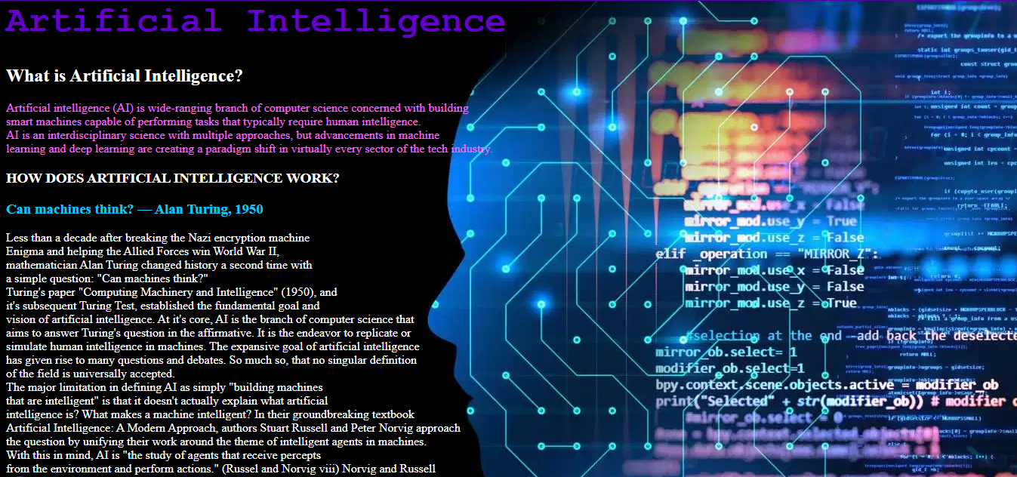

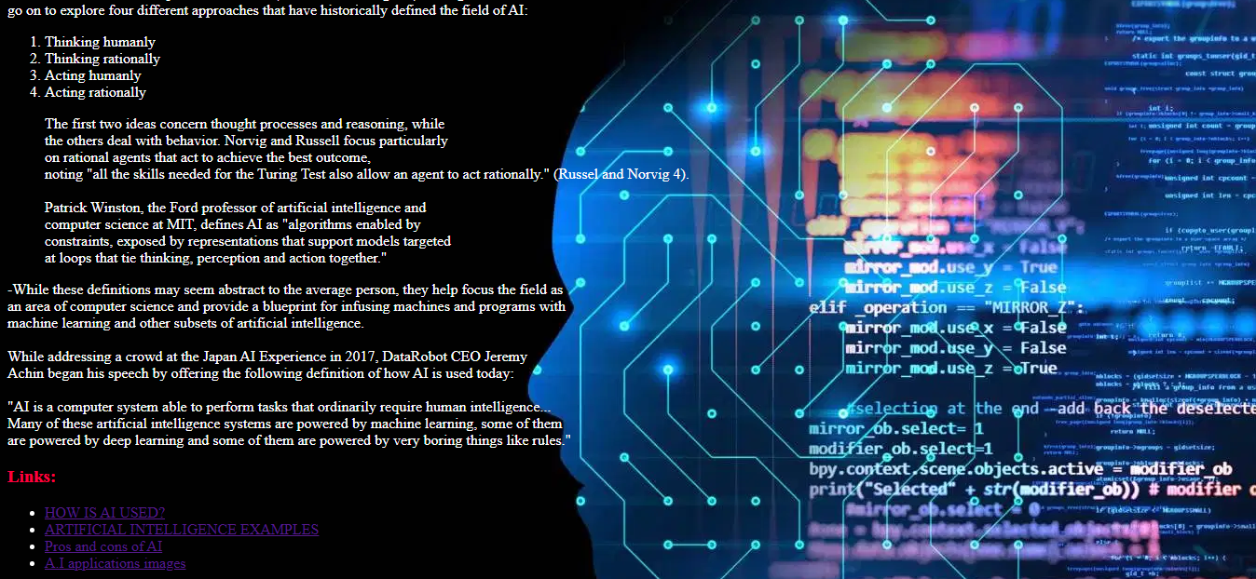

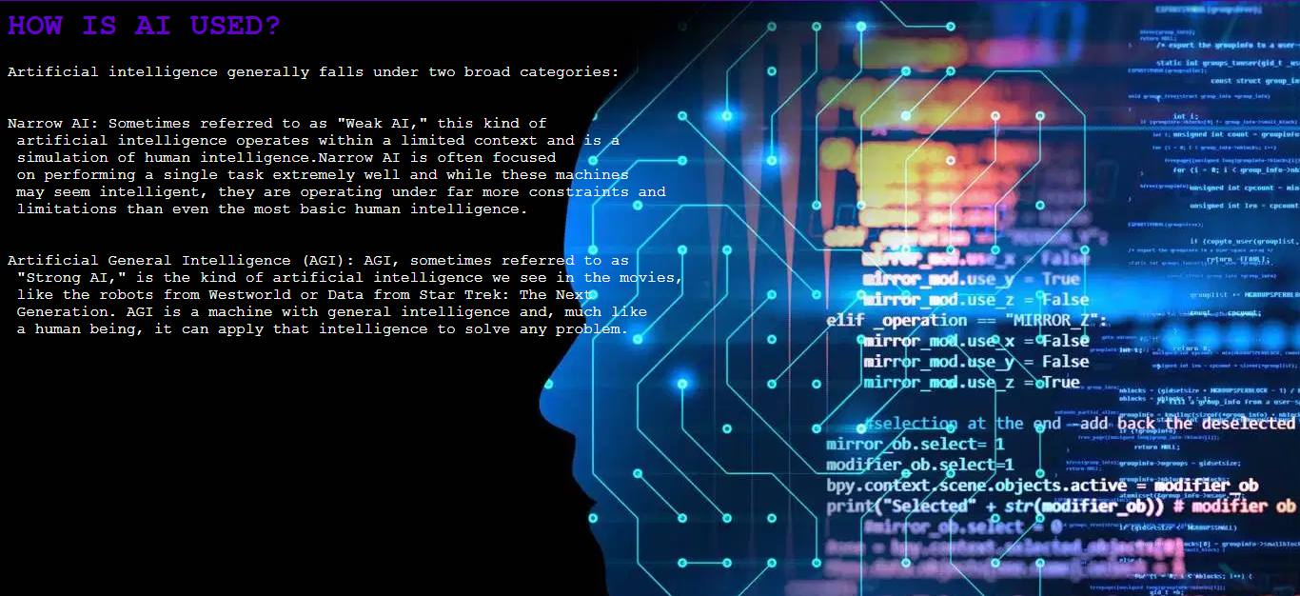

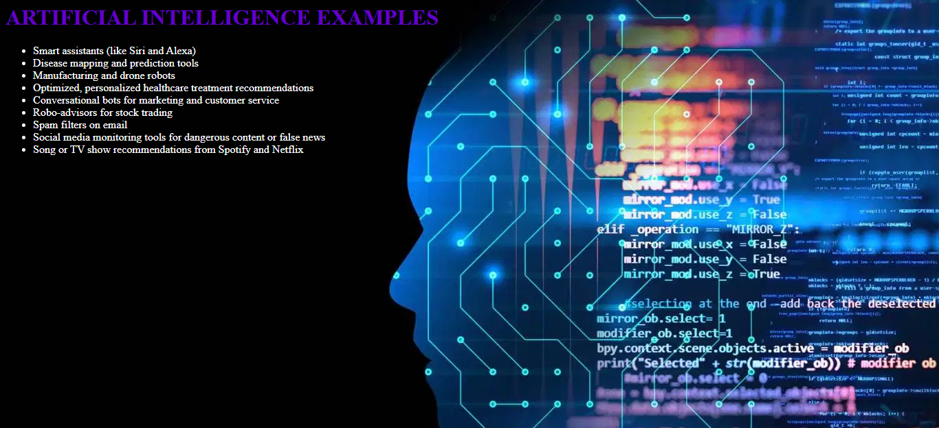

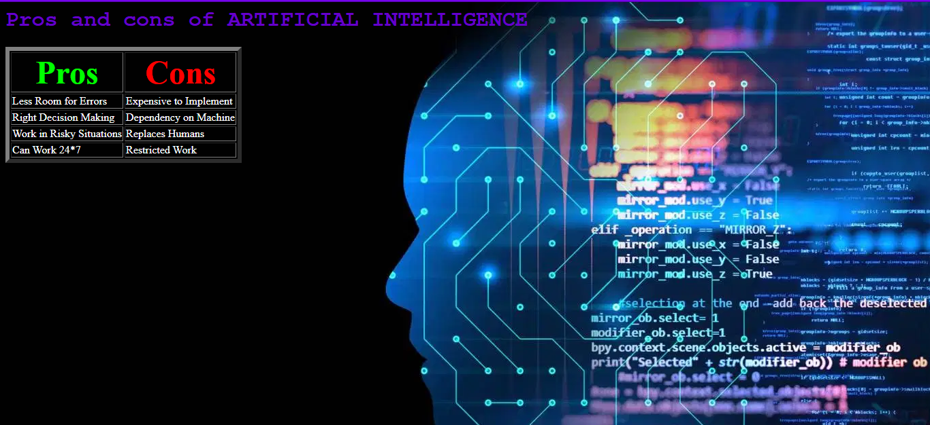

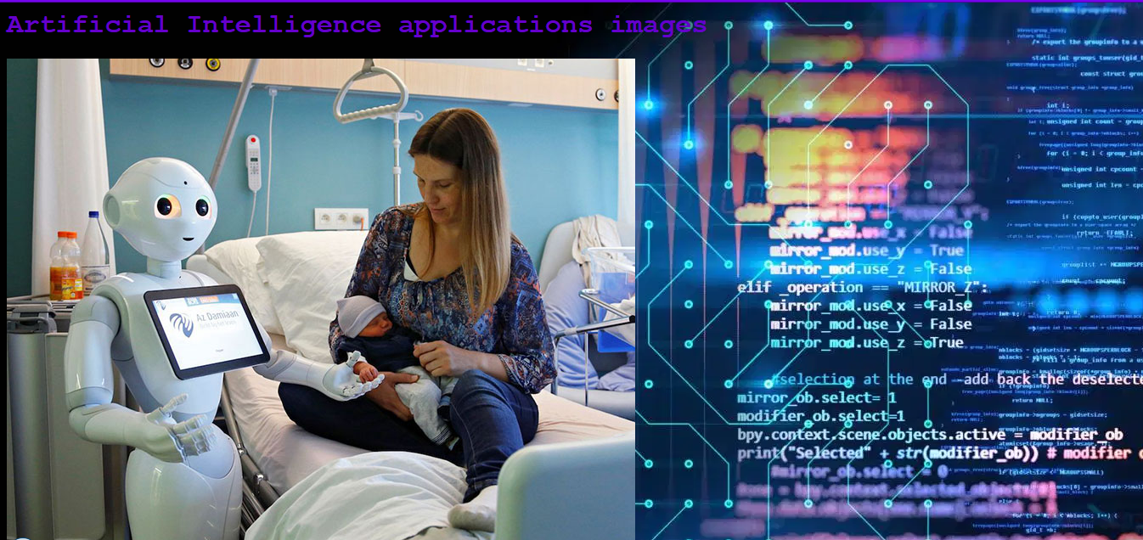

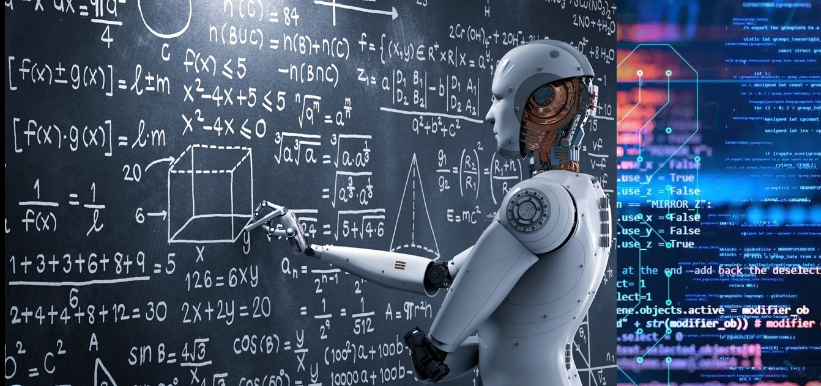

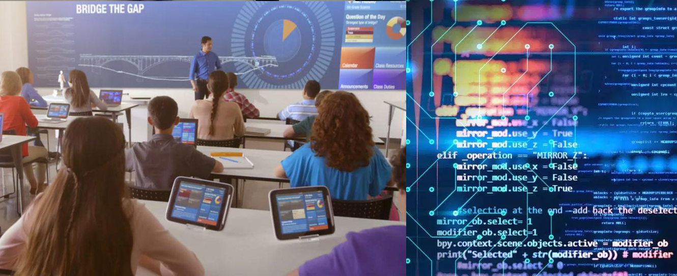

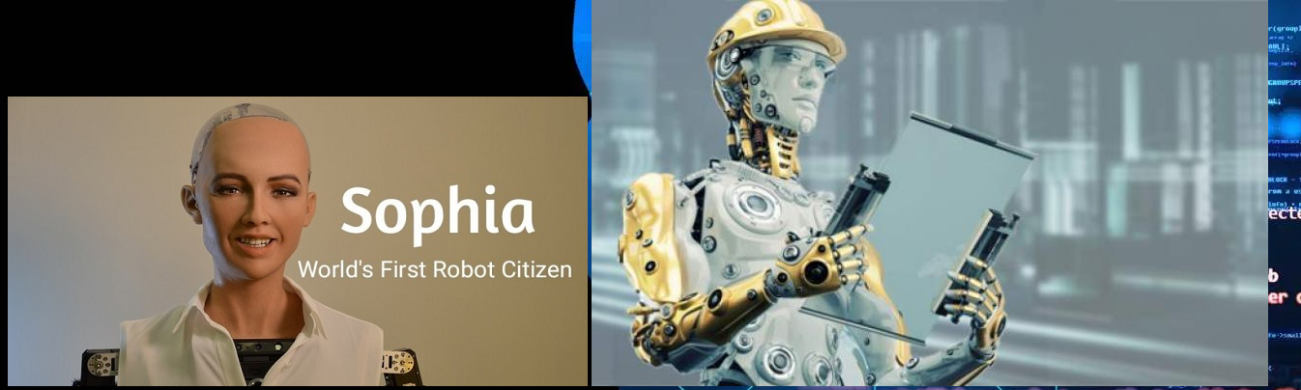

* 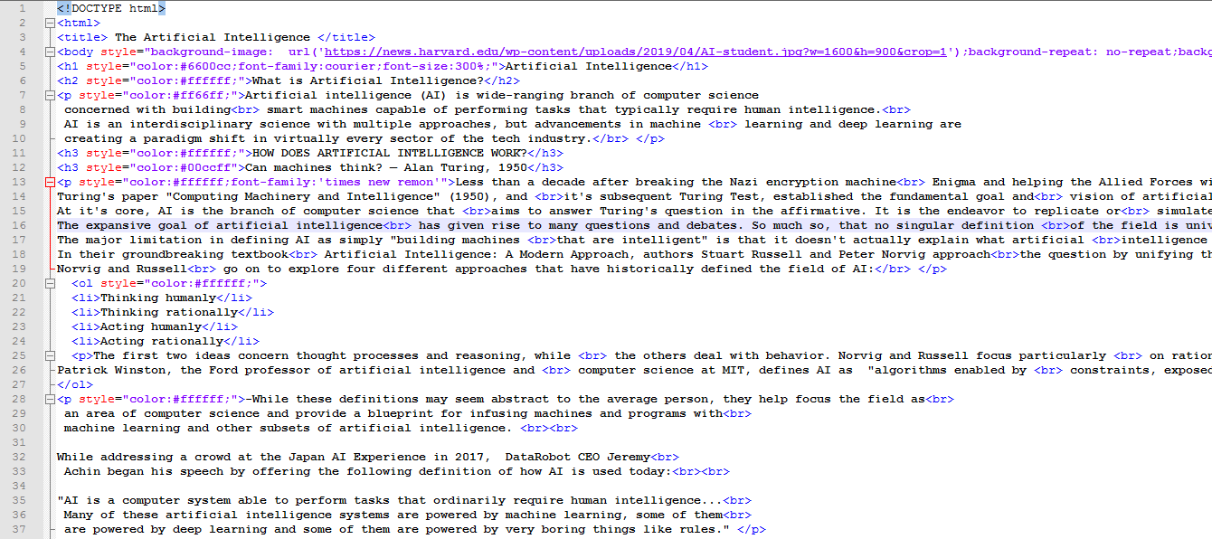**Source code:**

1. **Artificial Intelligence(the main page )**

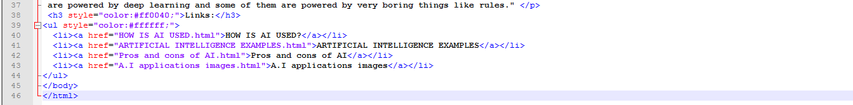

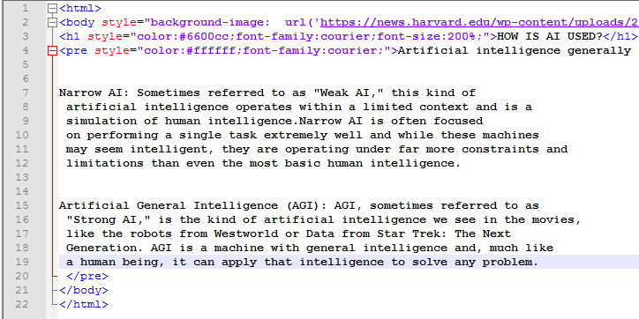

1. **How is Artificial Intelligence used**

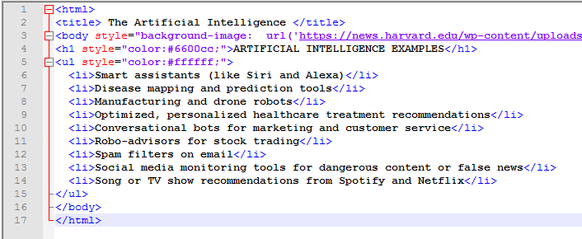

1. **Artificial Intelligence examples:**
2. **Pros and cons table of Artificial Intelligence**

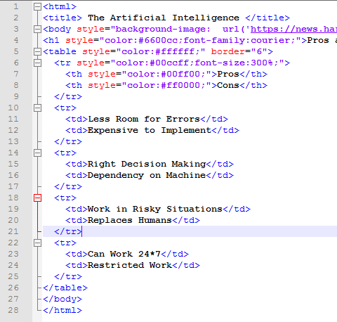

1. **Artificial Intelligence 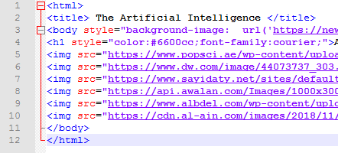images:**

**References**

1. Korb, Kevin B., and Ann E. Nicholson. Bayesian artificial intelligence. CRC press, 2010.
2. Russell, Stuart, and Peter Norvig. "Artificial intelligence: a modern approach." (2002).
3. Bratko, Ivan. Prolog programming for artificial intelligence. Pearson education, 2001.
4. Brougham, David, and Jarrod Haar. "Smart technology, artificial intelligence, robotics, and algorithms (STARA): Employees’ perceptions of our future workplace." Journal of Management & Organization, 2018.